**SENIOR ADVISORY COMMITTEE**

**Gus Velasco Neighborhood Center**

**Tuesday, April 9, 2024**

**9:30 a.m.**

**MINUTES**

1. CALL TO ORDER – Chairperson Janie Aguirre called the meeting to order at 9:31 a.m.
2. ROLL CALL

*Members Present:* Gilbert Aguirre, Janie Aguirre, Dolores Duran, Bonnie Fox, Hilda Zamora, Astrid Shesterkin, Dolores Romero, Josefina Lara, Paul Nakamura, Yoko Nakamura, Johnny Hernandez, Nancy Krueger

*Members Absent:* None.

*Staff:* Jose Carrillo, Community Services Supervisor/Executive Secretary

Ed Ramirez, Family and Human Services Manager

Adriana Duran, Administrative Clerk

*Guests:* None.

1. PLEDGE OF ALLEGIANCE – Johnny Hernandez
2. ORAL COMMUNICATIONS

None.

1. APPROVAL OF MINUTES

Item 1: Amend to read:

“Chairperson Janie Aguirre called the meeting to order at 9:30 a.m.”

Item 13: Amend to read:

“Chairperson Janie Aguirre adjourned meeting at 10:31 a.m.”

A motion was made by Johnny Hernandez and seconded by Dolores Duran to approve the minutes for the March 12, 2024 meeting as corrected.

1. PRESENTATIONS
2. *Art Fest Update*

Mr. Ramirez delivered a presentation outlining the forthcoming Art Fest event. During the session, he guided the committee members through an overview of the event map, explained the entry fees for both nights, and detailed the offerings, including beer and wine tasting, paint n’ sip activities, and the entertainment schedule.

1. EXECUTIVE SECRETARY REPORT

Mr. Carrillo reported on the following to the committee:

1. *Children’s Boutique Recap*

Mr. Carrillo presented a summary of the Children’s Boutique initiative, highlighting that 84 families received clothing, amounting to a distribution of 154 bags. He also conveyed appreciation for the support extended by the members.

1. OLD BUSINESS

None.

1. NEW BUSINESS
2. *Senior Mingle in Downey*

In collaboration with the City of Downey, the Senior Mingle will be hosted on April 17th from 1:00 – 6:00 p.m. Tickets are almost sold out, Mr. Carrillo encouraged members to register.

1. *Southeast Los Angeles Senior Dance*

Additionally, the Southeast Los Angeles Senior Dance is set for May 4th from 12:00 to 4:00 p.m., with the bus departing from Gus Velasco Neighborhood Center at 11:00 a.m.

1. *Advisory Member Attendance Policy Update*

Mr. Ramirez briefed members on the ongoing review of the attendance policy, further details will be provided once available.

1. DEPARTMENT OF COMMUNITY SERVICES REPORT

Executive Secretary Carrillo provided a brief overview of the older adult programming that is currently in session and the upcoming special events.

1. *Family and Human Services Division Program and Project Updates*
2. Bingo takes place Tuesdays – Fridays (unless there is a Friday activity) from 9:30 – 11:30 a.m.
3. Games and Fun takes place Tuesdays and Thursdays from 9:00 a.m. to 12:00 p.m.
4. Create-it Now takes place on February 26th, March 25th, and April 29th from 9:30 – 11:00 a.m.
5. Monthly Birthday Cake Celebrations take place on the last Wednesday of the month at 11:45 a.m.
6. Café con José takes place on the last Thursday of the month at 11:45 a.m.
7. Movin’ N’ Groovin’ Chair Exercise classes take place on Mondays and Wednesdays from 8:15 – 9:15 a.m.
8. Pickleball takes place on Mondays and Wednesdays at Los Nietos Park from 9:00 – 10:30 a.m.
9. Latin Dance Cardio takes place on Mondays and Wednesdays from 10:00 – 11:00 a.m.
10. Yoga takes place on Mondays from 1:00 – 2:20 p.m.
11. Garden Fun Under the Sun takes place on Mondays from 8:30 – 11:00 a.m.
12. Spring Fling Dance will take place on Friday, April 19th from 9:00 a.m. – noon. Tickets will be on sale for $10 for residents beginning April 1st and for non-residents beginning April 8th.
13. Wood Block Painting Classes will take place on Tuesdays from April 2nd through April 23rd from 1:00 – 2:30 p.m.
14. Rock Painting classes will take place on Wednesdays from April 3rd through April 24th from 1:00 – 2:30 p.m.
15. Sensational Salads classes will take place on Thursdays from April 4th through April 25th from 1:00 – 2:30 p.m.
16. Machine Sewing classes will take place the first and third Monday of the month until April 15th between 8:30 – 11:00 a.m.
17. Mother’ Day event will take place on May 10 between 9:30 – 11:30 a.m.
18. FUTURE AGENDA ITEMS

* Committee members proposed the inclusion of a council member or staff member to relay information regarding new projects within each department of the city.

1. MEMBERS COMMENTS/ANNOUNCEMENTS

* Members suggested having a mariachi group perform during the Mother’s Day event.

1. ADJOURNMENT – CHAIRPERSON JANIE AGUIRRE

Chairperson Janie Aguirre adjourned the meeting at 10:48 a.m.

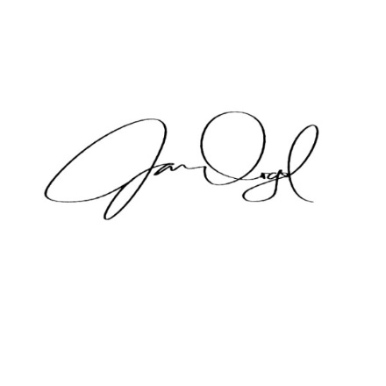**The Next Meeting of the Senior Advisory Committee will be held in-person at the Gus Velasco Neighborhood Center on May 14, 2024.**

Jose Carrillo, Executive Secretary Jasmine Oregel, Administrative Assistant II